Bus Reservation System


Session 2026 – 2030

Submitted by:
Hafiz Muhammad Ahmad 2026 – S -CS -8

Supervised by:
SIR LAEEQ UL ZAMAN KHAN NIAZI
Course:
CSC-102 Programming Fundamentals

Department of Computer Science
University of Engineering & Technology Lahore

Table of Contents
1. About Bus Reservation System 2
➢ Contribution 2
➢ Key Features 2
2. Users of Applications 3
➢ Administrator 3
➢ Manager 3
➢ Passenger 3
3. Functional Requirements 4
4. Wireframes 5
➢ Startup Interface 5
➢ Admin menu 5
➢ Manager menu 6
➢ Passenger menu 6
5. Data structures 6
6. Function prototypes 7

About Bus Reservation System
The Bus Reservation System is a computer-based application designed to automate the process of booking bus tickets, managing passengers, and handling bus information. It replaces the traditional manual system with a fast, accurate, and user-friendly digital solution.

➢ Contribution
The Bus Reservation System automates ticket booking to reduce manual work and save time for both passengers and staff. It minimizes errors such as duplicate bookings, improves management of passenger and bus records through digital storage, and provides a simple and transparent way to check availability and reserve seats, making the overall process more efficient and reliable.

➢ Key Features
The key features of the Bus Reservation System include passenger signup and login with email and password validation, management of bus details and seat availability, ticket booking and cancellation, real-time seat management, secure storage of data using file handling, and a simple, user-friendly interface that ensures an efficient and error-free reservation process.

Users of Applications
The Bus Reservation System is used by three main types of users: administrators, managers, and passengers. Administrators handle overall system control, manage bus information, and monitor operations. Managers assist in day-to-day management, such as updating schedules, assigning buses, and overseeing bookings. Passengers use the system to sign up, log in, view available buses, and book or cancel tickets.

➢ Administrator
The Administrator is the primary user responsible for overall control of the Bus Reservation System. They can add, update, or delete bus details, manage passenger and manager accounts, and monitor all reservations. The administrator ensures the system runs smoothly, maintains data accuracy, and has full access to all system operations, making them the highest-level authority within the application.

➢ Manager
The Manager in the Bus Reservation System helps in daily operations and has access to important management features. They can view all buses, view active buses, search for a specific bus, and check seat availability. While they do not have full administrative control, managers ensure smooth functioning by monitoring buses and reservations, assisting passengers, and supporting the administrator in managing the system efficiently.

➢ Passenger
The Passenger is the end user of the system who books and manages their bus travel. Passengers can sign up and log in, view available buses, check seat availability, book tickets, and cancel reservations if needed. The system ensures a convenient and secure experience for passengers by validating their information, preventing duplicate bookings, and storing their data safely.

Functional Requirements
Expected functionalities according to types of users:
User Type | Functionalities | Results
Manager | View all buses | View the details of buses in Tabular form
 | View Active buses | Check the status of the bus whether it is active or inactive
 | View available seats | View the available seats for passengers of all buses
 | Logout | Manager can logout and go back to main menu
Admin | Manage buses | Can manage the buses for passengers
 | Add bus | Add a new using bus number, type and seats
 | Update bus | Update existing bus using bus number
 | Delete bus | Delete existing bus using bus number
 | Manage Fare | Manage the fare of AC and non-AC buses
 | Add fare | Add the fare of type AC and non-AC max
 | Update fare | Can update existing fare of type AC and non-AC
 | Logout | Admin can logout and go back to main menu
Passenger | View available buses | View available buses for booking
 | Search bus | Passengers can search bus using bus number
 | Book seat | Passenger can book seat in specific bus
 | Cancel booking | Can cancel the booked seat
 | logout | Passenger can logout and go back to main menu

Wireframes
A few wireframes of this application displayed in command line interface are as follows:

➢ Startup Interface
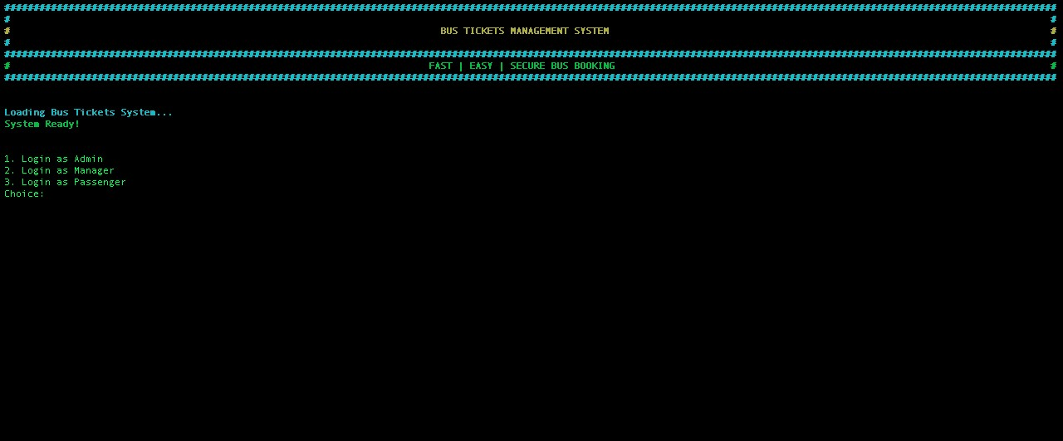

➢ Admin menu
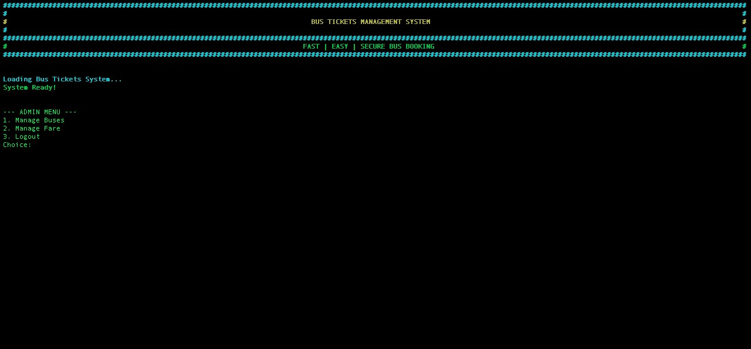

➢ Manager menu
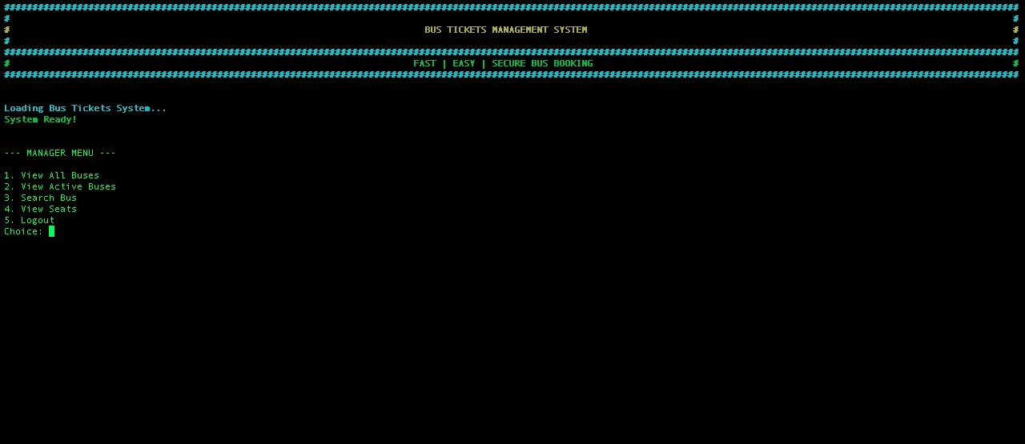

➢ Passenger menu
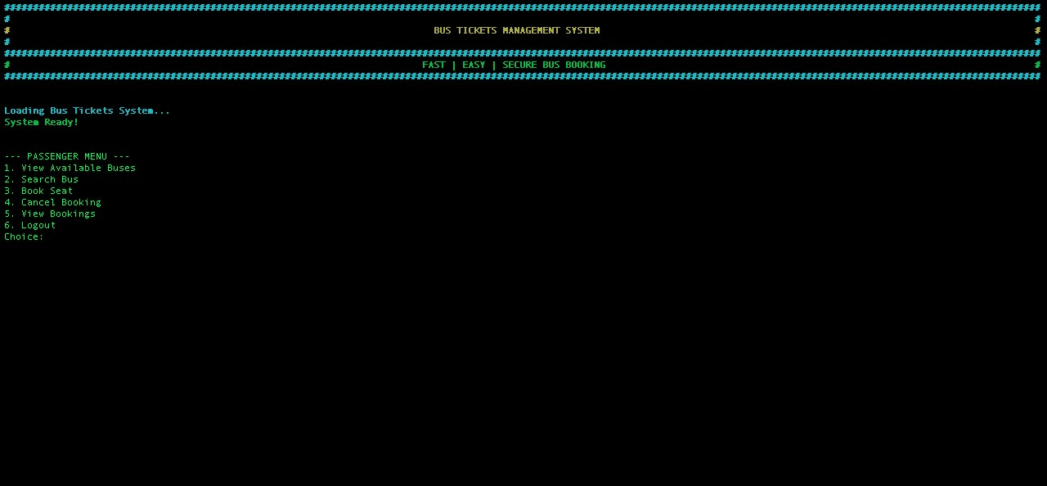

Data structures

string busNo[MaxBuses]; string busType[MaxBuses]; int busSeats[MaxBuses]; string busStatus[MaxBuses]; string passengerPassword[MaxPassengers]; int bookedSeats[MaxBuses] = {0}; string passengerEmail[MaxPassengers]; string managerEmail = "manager@btms.com"; string adminemail = "admin@btms.com"; string managerPassword = "manager@123"; string adminpassword = "admin@123"; const int MaxBuses = 50;
const int MaxPassengers = 50; const int MaxAdmin = 5; int adminCount = 0; int busCount = 0; int passengerCount = 0;

Function prototypes

void header(); void adminMenu();
void managefare(int ACbusfare, int nonACFare); void addfare(int ACbusfare, int nonACFare); void viewfare(int ACbusfare, int nonACFare); void updatefare(int ACbusfare, int nonACFare); void manageBuses(); void addBus(); void showBus(); void updateBus(); void deleteBus(); void changeBusStatus(); void loadPassengers(); void passengerSignup(); bool passengerLogin(); bool validEmail(string email); bool validPassword(string pass);

- About Bus Reservation System: .............................................................................. 2
  - Contribution: ..................................................................................................... 2
  - Key Features: ..................................................................................................... 2
- Users of Applications: ............................................................................................ 2
  - Administrator: ................................................................................................... 2
  - Manager: ........................................................................................................... 3
  - Passenger: ........................................................................................................ 3
- Functional Requirements: ...................................................................................... 3
- Wireframes: .......................................................................................................... 4
  - Startup Interface: ............................................................................................... 4
  - Admin menu: ..................................................................................................... 5
  - Manager menu: .................................................................................................. 5
  - Passenger menu: ............................................................................................... 6
- Data structures: .................................................................................................... 6
- Function prototypes: ............................................................................................. 7

- About Bus Reservation System: .............................................................................. 2
  - Contribution: ..................................................................................................... 2
  - Key Features: ..................................................................................................... 2
- Users of Applications: ............................................................................................ 2
  - Administrator: ................................................................................................... 2
  - Manager: ........................................................................................................... 3
  - Passenger: ........................................................................................................ 3
- Functional Requirements: ...................................................................................... 3
- Wireframes: .......................................................................................................... 4
  - Startup Interface: ............................................................................................... 4
  - Admin menu: ..................................................................................................... 5
  - Manager menu: .................................................................................................. 5
  - Passenger menu: ............................................................................................... 6
- Data structures: .................................................................................................... 6
- Function prototypes: ............................................................................................. 7

- About Bus Reservation System: .............................................................................. 2
  - Contribution: ..................................................................................................... 2
  - Key Features: ..................................................................................................... 2
- Users of Applications: ............................................................................................ 2
  - Administrator: ................................................................................................... 2
  - Manager: ........................................................................................................... 3
  - Passenger: ........................................................................................................ 3
- Functional Requirements: ...................................................................................... 3
- Wireframes: .......................................................................................................... 4
  - Startup Interface: ............................................................................................... 4
  - Admin menu: ..................................................................................................... 5
  - Manager menu: .................................................................................................. 5
  - Passenger menu: ............................................................................................... 6
- Data structures: .................................................................................................... 6 6. Function prototypes: ............................................................................................. 7
bool validPassword(string pass); void managerMenu(); bool managerLogin(); void adminEmailid(); void adminPassword();

void passengerMenu(); void viewAvailableBuses(); void bookSeat(); void cancelBooking(); void viewBookings();

